GURU Ji

Smart 21st Century Next Gen. AI-Based Professor

Table of Contents
- Introduction
  - 1.1. Objective
  - 1.2. Problem Statement
  - 1.3. Solution Overview
- System Architecture & Workflow
  - 2.1. High-Level Workflow Diagram
  - 2.2. Technology Stack
  - 2.3. Detailed Workflow
- Database Schema
  - 3.1. Schema Diagram
  - 3.2. Table Definitions
- Function-Level Documentation
  - 4.1. Core & Utility Functions
  - 4.2. Environment Setup Functions (Part A)
  - 4.3. Database Management Functions
  - 4.4. API Interaction Functions
  - 4.5. Video Generation Pipeline (Part B)
- Usage Guide & Examples
  - 5.1. Prerequisites
  - 5.2. Step-by-Step Guide
  - 5.3. Command Line Reference
- Future Scope & Improvements

1. Introduction

1.1. Objective
The primary objective of Project Guruji is to create a streamlined, automated pipeline for converting a professor's raw text notes into a complete, ready-to-watch video lecture. The system aims to minimize manual intervention by leveraging AI for text enhancement, voice cloning, and video synthesis.

1.2. Problem Statement
Educators often possess deep knowledge but may lack the time, technical skills, or resources to produce high-quality video content. The process of scripting, recording, editing, and producing a video lecture is laborious and time-consuming. This creates a significant barrier to creating scalable and engaging digital educational materials.

1.3. Solution Overview
guruji.sh is a comprehensive Bash script that orchestrates a series of tools and APIs to solve this problem. It manages the entire lifecycle of video creation through a simple command-line interface:
- Part A (Setup): A one-time setup process to configure the environment, install dependencies, and build a database of professor profiles and their cloned voices.
- Part B (Operations): A repeatable workflow where a professor can submit a text file and associated metadata, which the script automatically processes through a multi-step pipeline to generate the final video lecture.

2. System Architecture & Workflow

2.1. High-Level Workflow Diagram
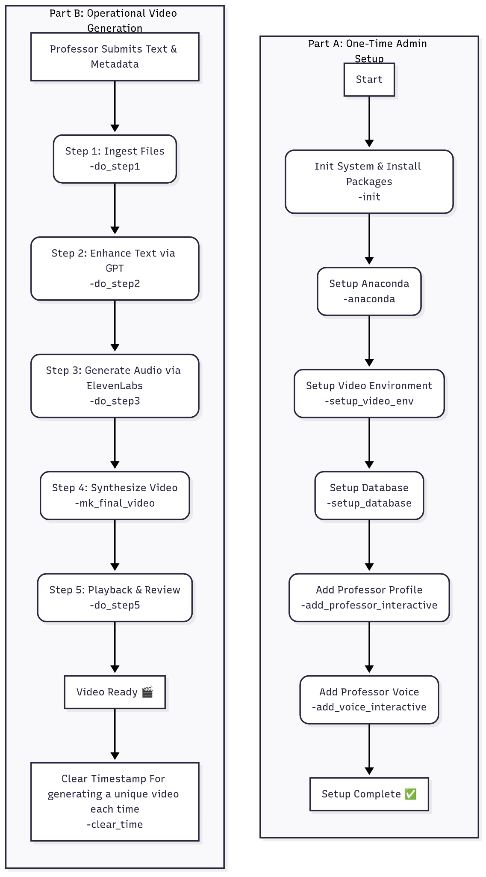

2.2. Technology Stack
- Orchestration: Bash Script (guruji.sh)
- Database: SQLite 3
- Environment Management: Anaconda
- Text Enhancement: OpenAI GPT-4 API
- Voice Cloning & TTS: ElevenLabs API
- Video Synthesis: video-retalking Python project
- Dependencies: curl, wget, jq, ffmpeg, git
2.3. Detailed Workflow
- Admin Setup: An administrator first runs the Part A commands sequentially. This prepares the Linux environment, installs Anaconda, creates a dedicated Python environment with all dependencies for the video-retalking model, and initializes an SQLite database. The admin then populates the database with professor profiles and uses audio samples to clone their voices via the ElevenLabs API, storing the resulting voice IDs.
- Lecture Ingestion: A professor starts the operational workflow by running do_step1. They provide URLs to a text file containing lecture notes and a JSON file with metadata (e.g., target audience, topic).
- AI Text Enhancement: The script sends the raw text and metadata to the GPT-4 API (do_step2). GPT-4 rewrites the notes into a structured, engaging lecture script.
- Text-to-Speech: The enhanced script is sent to the ElevenLabs API (do_step3), which uses the professor's pre-cloned voice to generate a high-quality audio file (.wav).
- Video Synthesis: The core video-retalking Python script is executed (do_step4). It takes a source video of the professor (e.g., a short clip of them speaking) and the newly generated audio file as input. The model animates the professor's face in the source video to match the new audio, creating the final lecture video.
- Playback: The final video can be immediately played back for review (do_step5).
- Clear Time: To create a unique video each time (clear_time)

3. Database Schema
The application uses a simple SQLite database (guruji.db) to manage persistent data.

3.1. Schema Diagram
- professors 1 -- 1 voice_ids (linked by professor_id)

3.2. Table Definitions
Table: professors
Stores the primary profile information for each professor. | Column | Data Type | Constraint | Description |
| :--- | :--- | :--- | :--- |
| professor_id | TEXT | PRIMARY KEY | A unique identifier for the professor. |
| professor_name| TEXT | | The full name of the professor. |
| age | INTEGER | | The professor's age. | | gender | TEXT |
| The professor's gender (e.g., "male", "female"). |
| accent | TEXT | | The accent for voice generation (e.g., "american"). |
Table: voice_ids
Links a professor to their unique voice ID from the ElevenLabs service.
| Column | Data Type | Constraint | Description |
| :--- | :--- | :--- | :--- |
| professor_id | TEXT | PRIMARY KEY | Foreign key linking to the professors table. |
| voice_id | TEXT | | The unique ID provided by the voice cloning service. |
Other Tables (Dynamically Created): The script also creates tables like gpt_outputs and audio_outputs to track the file paths of intermediate assets for each run, ensuring the correct files are passed between steps.

4. Function-Level Documentation

4.1. Core & Utility Functions
- g8_banner(): Prints a startup banner with script version, author, and system info.
- g8_check_root(): Verifies if the script is run with root privileges. Fails if not.
- g8_update(): Runs apt update and upgrade to ensure the system is up-to-date.
- g8_install_base(): Installs essential Linux packages like git, curl, vim, etc.
- g8_check_internet(): Pings a reliable IP to confirm internet connectivity.
- ensure_sqlite(): Checks if sqlite3 is installed and prompts the user to install it if missing.
- g8_clear_timestamp(): Deletes the .guruji_run_ts file to allow for fresh runs.
- g8_help(): Displays the command-line help message.
- g8_chk_fl(): Checks if a file path passed as an argument exists. Exits with an error if not.
- g8_exit_error() / g8_exit_success(): Standardized exit functions for failure and success.

4.2. Environment Setup Functions (Part A)
- g8_do_init(): The main initialization function. It checks for a signature file (/etc/guruji) to prevent re-runs. If not found, it performs system updates, installs base packages, creates necessary directories (/in, /ops, /out), and leaves the signature file.
- g8_setup_anaconda(): Manages the installation of Anaconda. It checks if the user is non-root and if Anaconda is already installed. It then downloads and runs the Anaconda installer script.
- g8_setup_video_env(): Clones the video-retalking git repository, creates a dedicated Conda environment (video_retalking), activates it, and installs all required Python packages via conda and pip.
- g8_get_checkpoints(): Downloads the pre-trained model checkpoints and other assets required by the video-retalking project from Google Drive using gdown.

4.3. Database Management Functions
- setup_database(): Creates the guruji.db file and defines the professors and voice_ids tables if they don't already exist.
- display_database(): Prints the contents of all tables in the database to the console in a formatted way.
- upsert_professor_db_entry(): Takes professor details as arguments and performs an INSERT or UPDATE operation on the professors table.
- upsert_voice_id_entry(): Takes a professor_id and voice_id and performs an INSERT or UPDATE on the voice_ids table.
- take_professor_entry_interactive(): Provides an interactive command-line prompt to guide the user through adding a new professor's details.
- take_voice_id_entry_interactive(): An interactive prompt for adding a voice ID. It gives the option to either upload a new audio sample to ElevenLabs or enter a known voice ID manually.

4.4. API Interaction Functions
- g8_elab_add_voice(): Uploads a local audio file to the ElevenLabs API to create a new voice clone. It constructs the multipart/form-data request with metadata from the database (age, gender, accent) and stores the returned voice_id.
- g8_elab_del_voice(): Deletes a voice from the ElevenLabs account using its voice_id and removes the corresponding entry from the local database.
- g8_step2_gpt_conv_to_lecture(): Constructs a JSON payload containing the system prompt, user's raw text, and metadata. It sends this to the OpenAI GPT-4 API via curl, extracts the enhanced lecture text from the response, and saves it to a file.
- g8_step3_conv_txt_to_wav(): Reads the enhanced lecture text from the file generated in Step 2. It sends this text to the ElevenLabs Text-to-Speech API endpoint along with the professor's voice_id to generate the audio file.

4.5. Video Generation Pipeline (Part B)
- g8_step1_get_from_prof(): Prompts the user to enter URLs for the lecture text file and the metadata JSON file. It then uses wget to download these files into the /in directory.
- g8_step2_gpt_conv_to_lecture(): Constructs a JSON payload containing the system prompt, user's raw text, and metadata. It sends this to the OpenAI GPT-4 API via curl, extracts the enhanced lecture text from the response, and saves it to a file.
- g8_step3_conv_txt_to_wav(): Reads the enhanced lecture text from the file generated in Step 2. It sends this text to the ElevenLabs Text-to-Speech API endpoint along with the professor's voice_id to generate the audio file.
- g8_run_prog(): The core video synthesis function. It activates the video_retalking Conda environment, prompts the user for the paths to the source video and the generated audio, and then executes the inference.py script with the correct arguments to produce the final video.
- g8_video_interactive_playback(): Uses cvlc (VLC media player command-line) to play the final output video file for immediate review.
- g8_clear_timestamp(): Helps in getting unique file name for each video generation

5. Usage Guide & Examples

5.1. Prerequisites
- A Debian-based Linux system (e.g., Ubuntu 22.04).
- sudo or root access.
- API keys for OpenAI (GPT-4) and ElevenLabs.
Create a file named .env in the script's directory with the following content:
G8_CGPT_KEY="your_openai_api_key"
- G8_ELAB_KEY="your_elevenlabs_api_key"

5.2. Step-by-Step Guide
First-Time Admin Setup: Run these commands sequentially one by one

# 1. Initialize system, install packages (run as root)
sudo ./guruji.sh -init
# 2. Install Anaconda (run as your regular user, NOT root)
./guruji.sh -anaconda
# --> Log out and log back in after this step.
# 3. Setup the video environment and download models (as regular user)
./guruji.sh -setup_video_env
# 4. Initialize the database (as regular user)
./guruji.sh -setup_database
# 5. Add a professor profile interactively
./guruji.sh -add_professor_interactive
# 6. Add a professor's voice (e.g., by uploading an audio sample)
./guruji.sh -add_voice_interactive

Operational Video Generation: Run these commands sequentially for each new lecture.

# 1. Provide URLs to your lecture text and metadata files
./guruji.sh -do_step1
# 2. Enhance the text using GPT
./guruji.sh -do_step2
# 3. Convert the enhanced text to audio using the cloned voice
./guruji.sh -do_step3
# 4. Generate the final video from an input video and the new audio
./guruji.sh -mk_final_video
# 5. Play the generated video
./guruji.sh -do_step5

5.3. Command Line Reference

Command | Description
-init / -reset | Part A: Initializes the system (requires root).
-anaconda | Part A: Installs Anaconda (requires non-root user).
-setup_video_env | Part A: Clones repo and sets up the Conda environment.
-setup_database | Initializes or verifies the SQLite database.
-add_professor_interactive | Interactively add a new professor to the DB.
-add_voice_interactive | Interactively link a voice to a professor.
-show_database | Displays all records in the database.
Command | Description
-do_step1 | Part B: Ingests professor's text and metadata files.
-do_step2 | Part B: Enhances text with GPT.
-do_step3 | Part B: Converts text to audio with ElevenLabs.
-mk_final_video | Part B: Synthesizes the final video.
-do_step5 | Part B: Plays the final video.
-clear_time | Unique file naming for each file.
-help | Shows the help message.

6. Future Scope & Improvements
- Web Interface: Develop a simple web UI (using Flask or Django) to replace the command-line interface, making the tool more accessible to non-technical users.
- Video Creation: Add functionality to create content slides.
- Interactive Support: Implementing dynamic interaction to clarify students doubts/ queries

